Face Parts
hair
hair
Write
eyebrow eyebroww

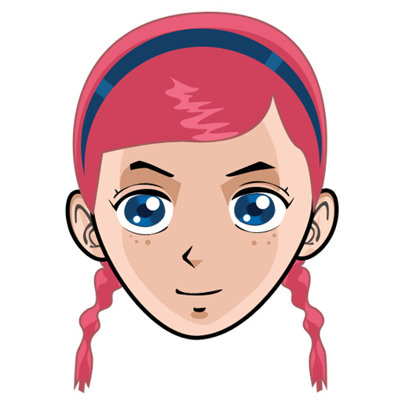
eye
eye
ear
ear
mouth
mouth
nose nose

chin chin

Face Parts
hair
hair
Write
eyebrow eyebroww

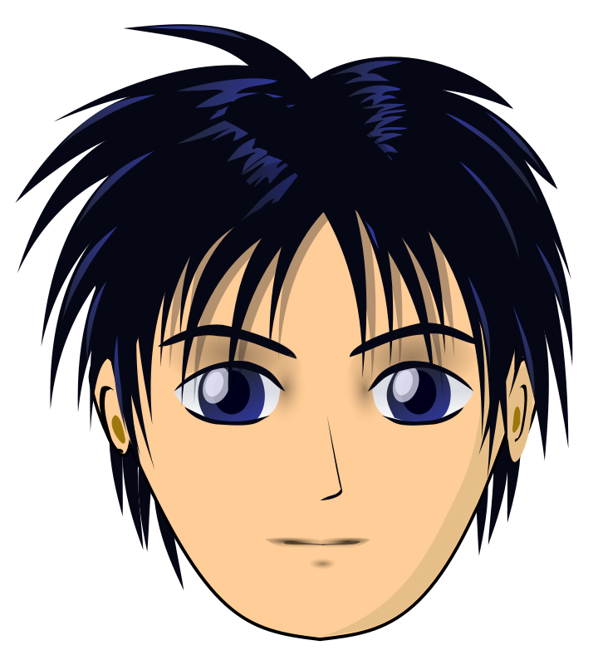
ear
ear
eye
eye
nose nose

mouth
mouth

chin chin
Face Parts
hair | eye | mouth
eyebrow | chin | nose
ear
Label the picture using the words in the table
h_______
e________
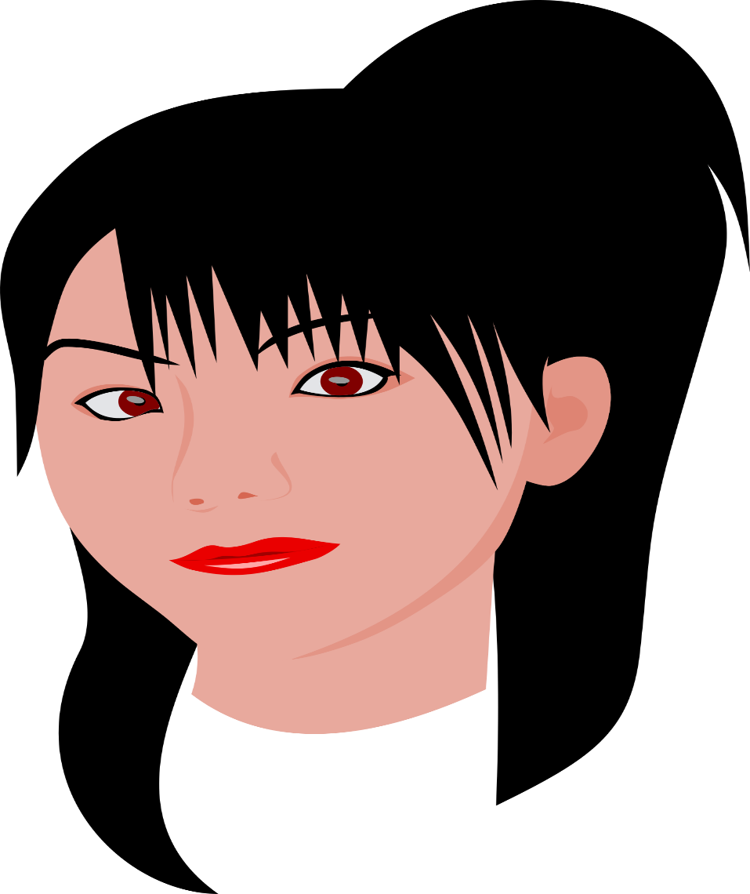
n____

e__
c_____
m______

e____

Body Parts
head
head
Write

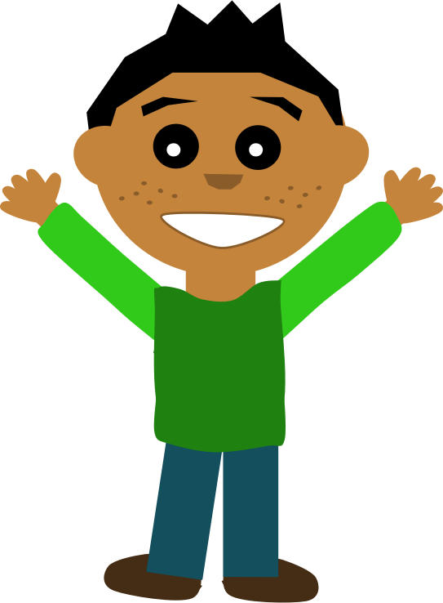
tummy
tummy
hand hand
arm
arm
leg leg

foot foot

Body Parts
head
head
Write

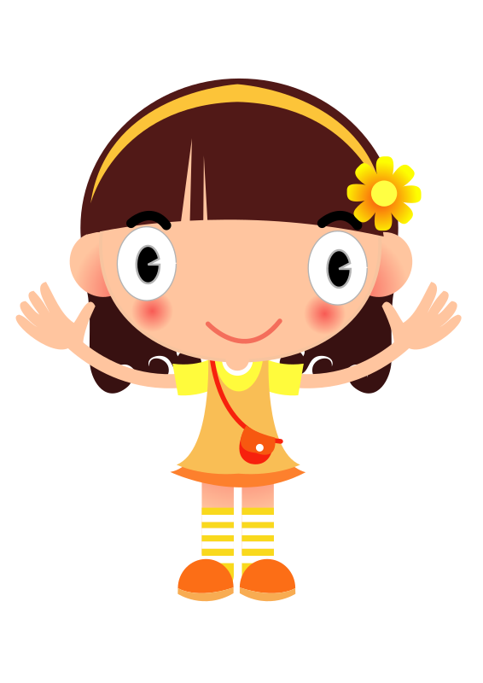
hand hand
arm
arm
tummy
tummy
leg leg

foot foot

Body Parts
leg | tummy | foot
arm | head | hand
Label the picture using the words in the table
h_______
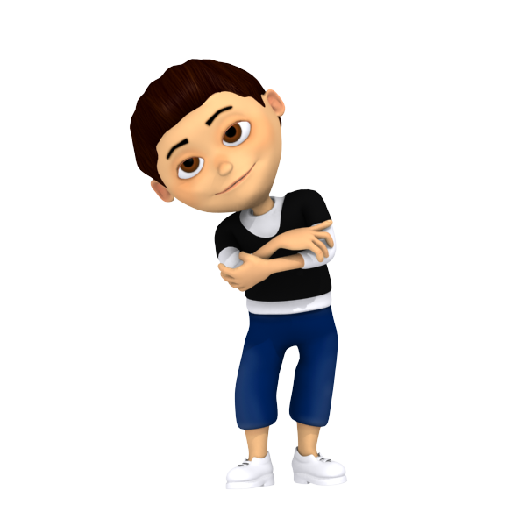
t______

h____
a____

f_____
l____

Face and Body Parts
1. hair | 2. eye | 3.mouth
4. eyebrow | 5. chin | 6. nose
7. ear | 8. leg | 9. arm
10. foot | 11. hand | 12. tummy

Label the picture

